1. select \* from salgrade;

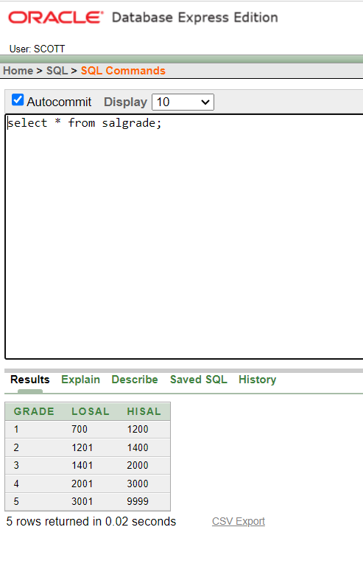

1. select deptno from dept;

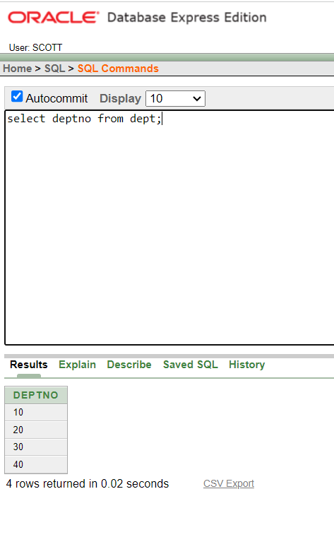

1. select (sal+sal\*0.05) "5% Increment" from emp;

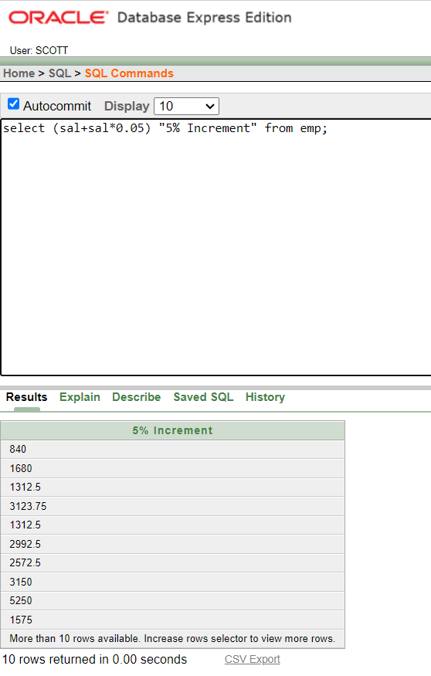

1. select ename,sal, (sal+sal\*0.05) "5% Increment" from emp;

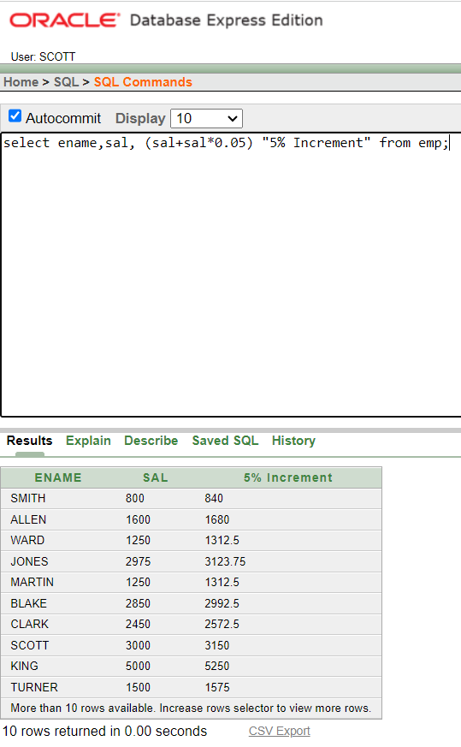

1. select \* from emp where ename='BLAKE';

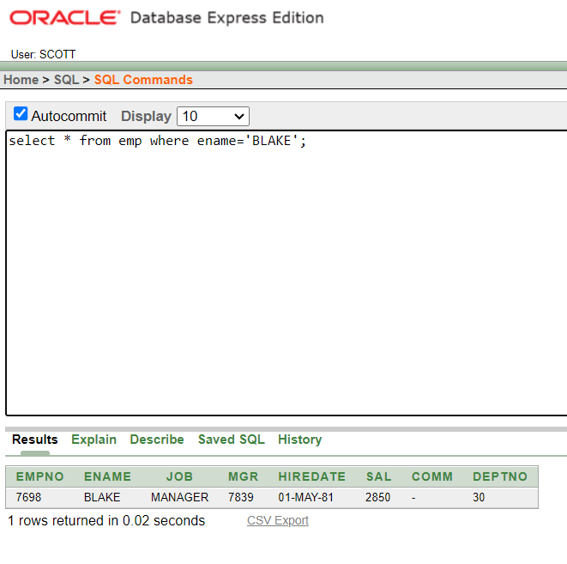

1. select ename||' is hired on '||hiredate||' as a '||job "Description" from emp where hiredate between '17-dec-80' and '28-sep-81';

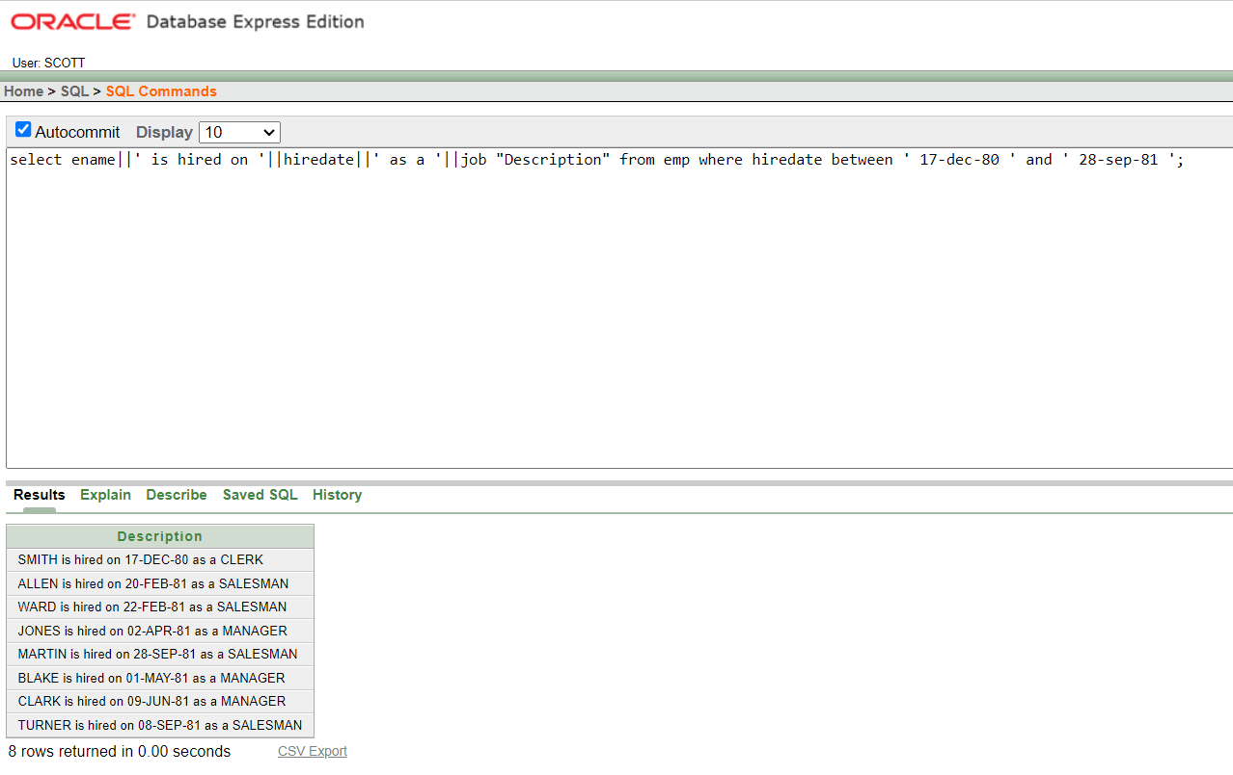

describe emp;

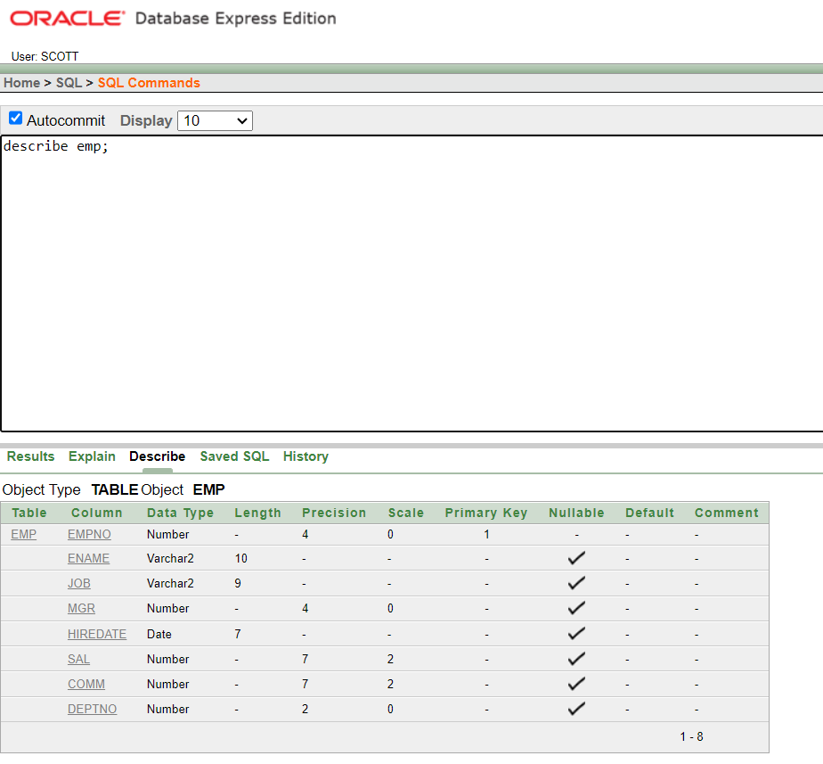

describe salgrade;

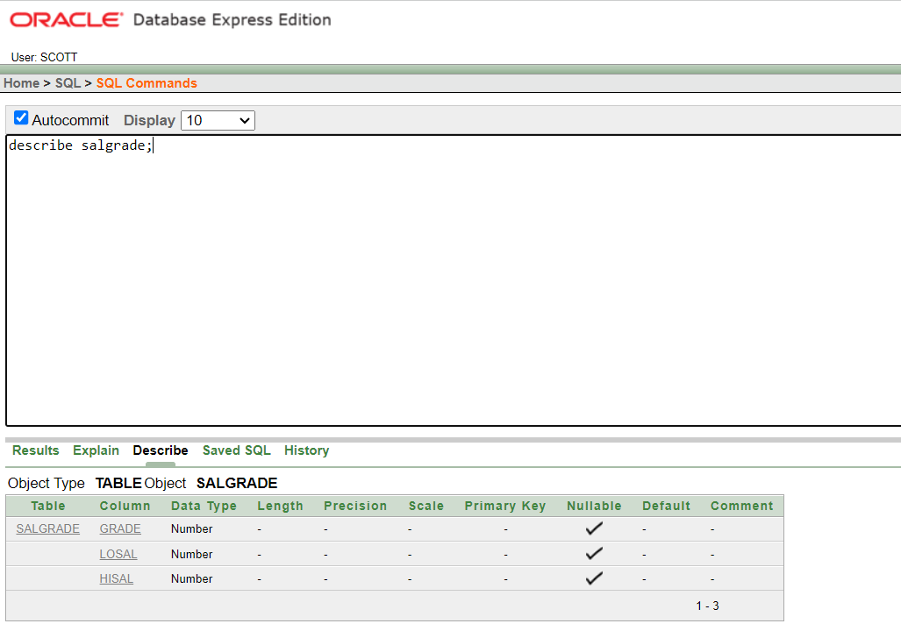

describe dept;

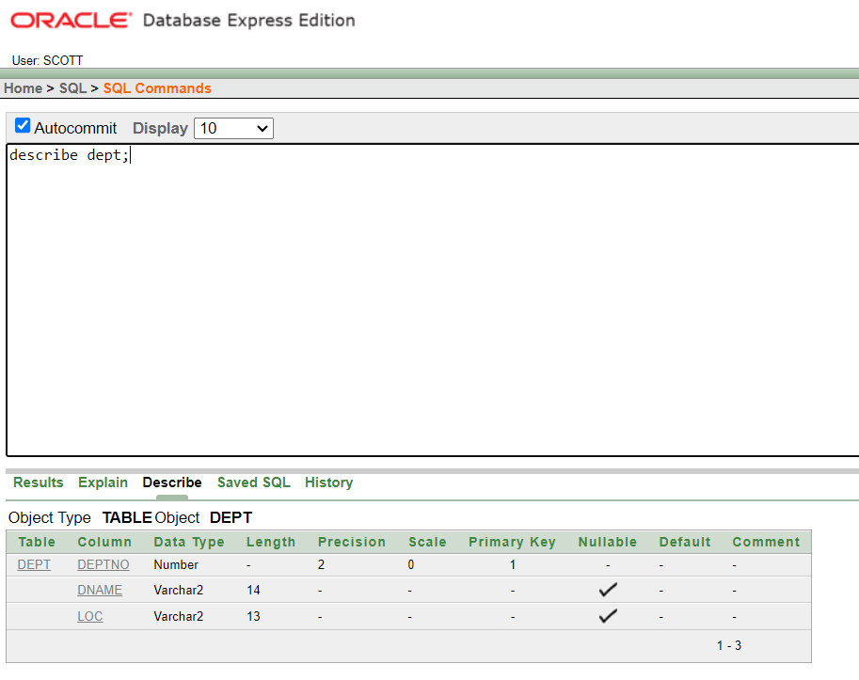

describe bonus;

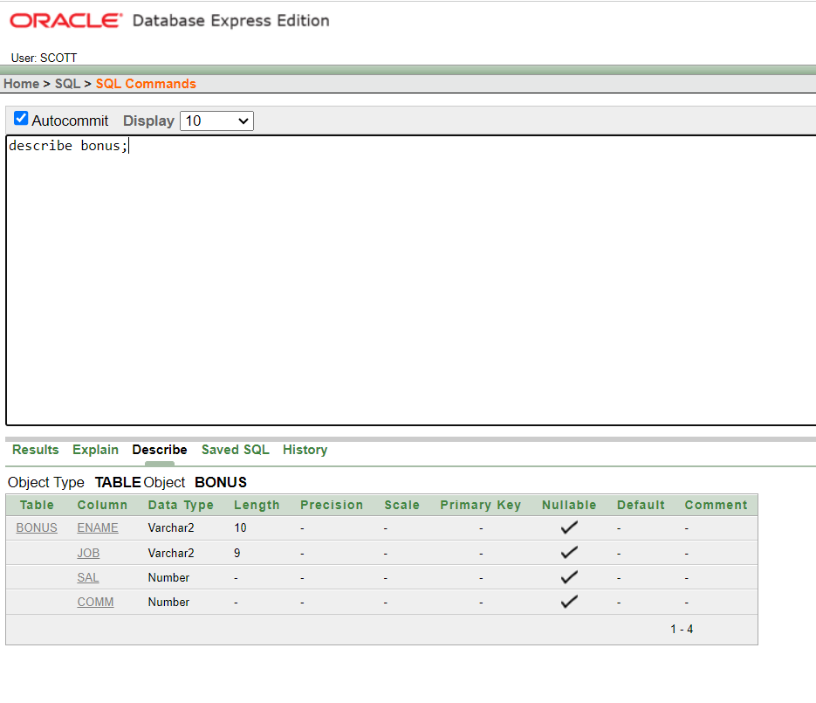

1. select distinct job from emp;

